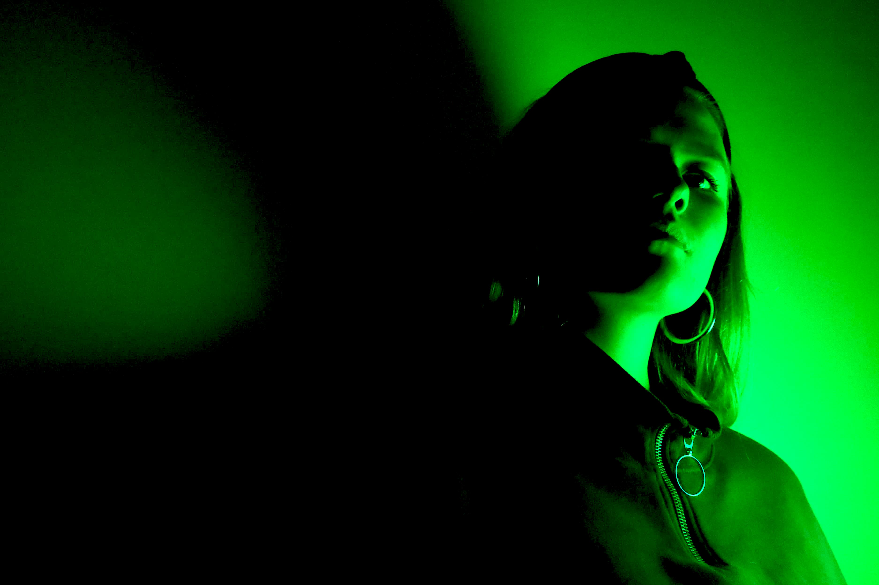WEB DESIGN

Sophie Georgin | 1702996

Word Count | 2,257

# Summary

This report outlines in depth the planning, reasoning and design process for a fictitious website for Sophie Georgin, a freelance Videographer. The aim of this website is to create a space for Sophie to market herself as a videographer, where potential clients can come and view her work. This report takes into consideration Sophie’s target audience and how the website was designed in order to attract each type of persona. This report outlines each individual stage of the design process, which allowed the website to come together as one piece. A competitor analysis is conducted, outlining the pros and cons of the websites of other video creators in the Aberdeen Area.

Table of Contents

Summary 1

The client 3

Client aims 4

Target audience 6

DESIGN PROCESS 8

The mockup 9

Finer Details 10

Background 10

Color 10

Fonts 11

Icons 12

Delivery 13

Navigation 13

JQUERY 13

Flex-Box / Grid 14

Screen Adaptation 14

SEO 15

Competitors 15

References 21

# The client

Sophie Georgin is a Media graduate from the Robert Gordons University, Aberdeen and is seeking to launch her freelance career in the world of videography. She is flexible with her work and what she can produce for clients of hers from short films to music video she is willing to work with clients to discover how she can make their needs fit her skills. The entirety of the website will be focused around Sophie and the work she can provide. As a freelance videographer a website is extremely important its gives the audience an idea of what Sophie can offer. The website is built purely for the Sophie to be seen, there are hundreds of freelance artists out there that it is easy to get caught in a rut. Building a unique website for Sophie is necessary for her to stand out in the videography sector.

# Client aims

* **Market -** Sophie’s website allows her to market herself online as a film-maker. The website will allow for Sophie to be in control of how others see her, in the hope that people choose to work with her.
* **Professionalism -** The main aim of the website was for it to look professional yet creative at the same time, this is to be achieved through simplistic layout integrated with specific fonts and colors during the design process.
* **Credibility -** Having this portfolio site allows for others to become familiar Sophie’s work making them more willing to trust her with projects they may have. Providing solid proof of what work Sophie has done will build trust and credibility through her website.
* **Minimalism- “**A minimalist web-design strategy is one that seeks to simplify interfaces by removing unnecessary elements or content that does not support user tasks.” (Moran, 2015) Minimalism will be achieved through specific characteristics of Sophie’s website which is laid out in the design planning process. The website will be spread out on one page, with a menu toggle allowing the audience to be directed to the specific part of the page they wish. The website will also be using few colours on a plain coloured background for the website content to stand out.
* **Responsive –** In 2018, 58% of site visits were from mobile devices (Enge, 2018), there is a clear need for website to now be mobile compatible in 2019. Sophie’s website aims to be responsive i.e respond to the user’s behaviours. Thus meaning the website should adapt to any screen size changes the user may make and if the user is viewing on a tablet on mobile device.

# Target audience

The target audience for this website is both clients seeking videography work and potential employers.

**Clients**

Since Sophie is a freelance Film-maker her website is a place where people seeking videography work may look at to see if their needs can be met. Two of Sophie’s previous clients have been shown below;

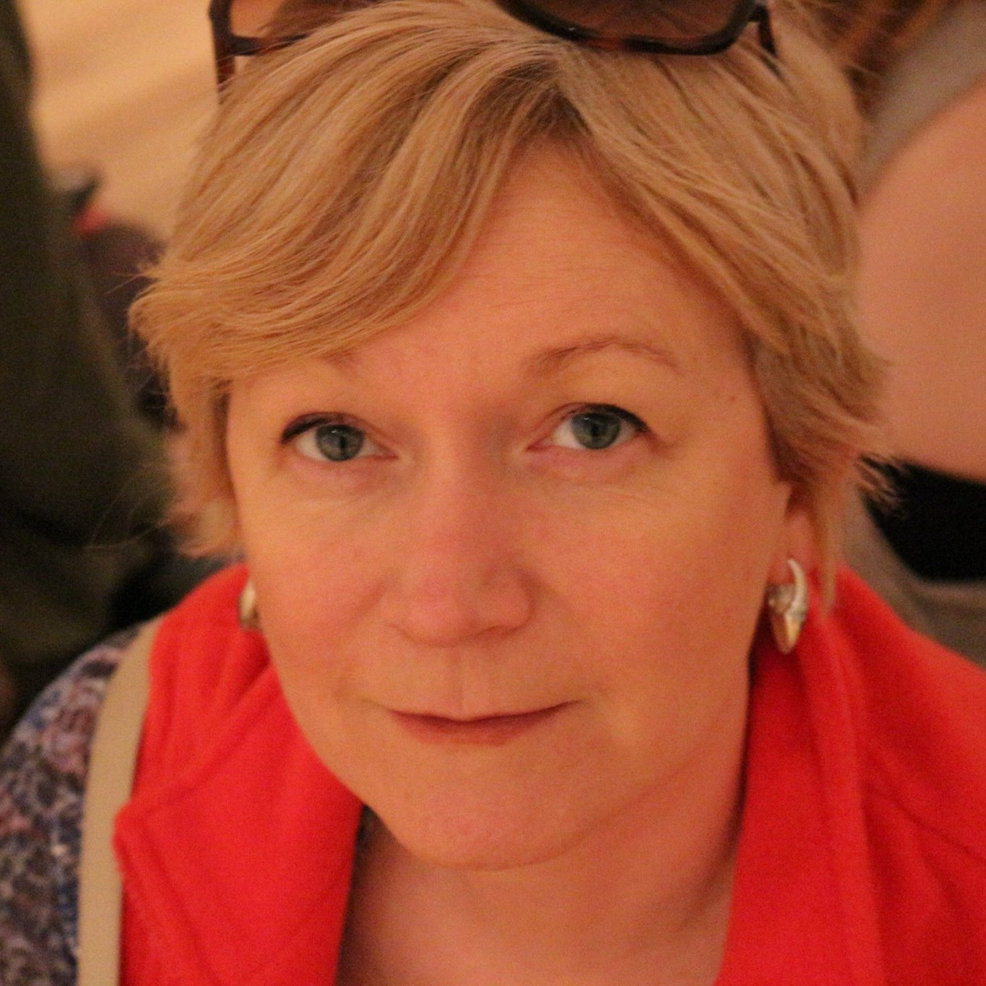Client #1

*Name- Sylvia Mary*

*Age – 52 years old*

*Occupation – Languages development officer, Aberdeenshire Council*

*Videography Knowledge – Little to none*

*Needs – Sylvia had all the materials, videos, photos etc. She needed them brought to life into a short 5 minute clip.*

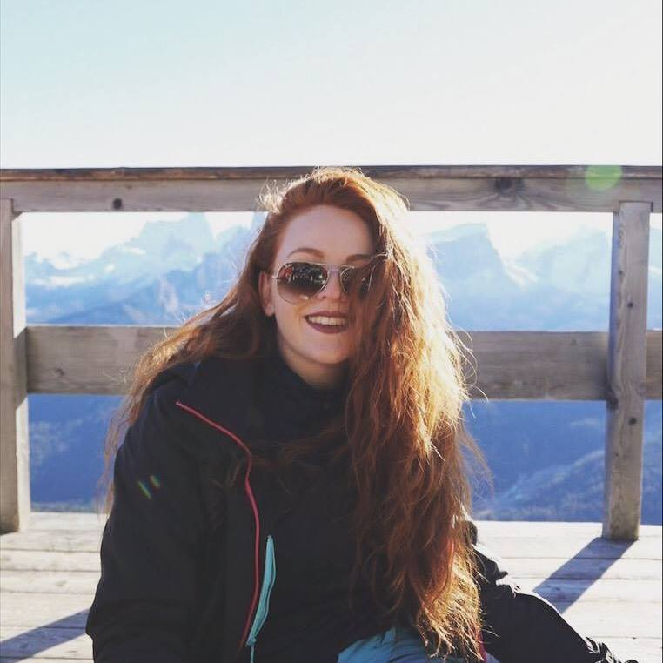Client #2

*Name – Kim Res*

*Age – 21 years old*

*Occupation – Student / Captain of Robert Gordons University Dance Team*

*Videography Knowledge – Kim was aware how she wanted the video to be executed*

*Needs- A video showcasing their new dance routine in a music video styled format.*

There is no specific niche of target audience for Sophie’s website. The only thing the target audience have in common is their need for a video project.

Sophie’s client criteria can range from individuals with little knowledge on videography to professionals looking to collaborate with Sophie. Therefore, it was important to keep the website highly visual and informative for professionals to view and relate to her work, but also easy to comprehend and navigate for those with less knowledge without them feeling overwhelmed.

# DESIGN PROCESS

*‘Our world is quickly becoming more and more digital. That means businesses will increasingly need to rely on websites to attract and retain their customers. An engaging website design encourages customers to do so.’ (Ramella, 2018)*

The design process was split into 3 separate parts. Firstly, the mockup, secondly finer details and lastly the delivery.

## The mockup

The mockup was first created using blocks and labels to define the websites structure (Appendix A). ‘*Mockup#1’* laid out the theme for the website. It was decided that for Sophie’s portfolio website a ‘One Page’ theme would be appropriate and professional. The one-page theme is a minimalistic theme that only requires one page of HTML. The one-page theme still allows for navigation links that allow the user to jump the particular content they wish to view.

*‘Mockup#1’* was then further developed into *‘Mockup#2’* using moqups.com (Appendix B). Using ‘Moqups’ allowed for a breakdown of where the text and media files were to be roughly positioned. Moqups allowed for shapes, texts, buttons to be positioned into a .pdf file that was used for reference in the initial HTML markup.

HTML

Once the website had been drawn out, it was time to begin to form the backbones of the site using HTML.

The HTML was written out in order of how the page could be scrolled down section by section;

* Landing page (Home)
* About
* Services
* Portfolio
* Timeline
* Contact
* Footer

Each section of HTML was organized using <section> tags. Within each section <div> tags were used along with a class in order to group block elements together to be able to format them using CSS later on.

## Finer Details

The next stage in the design process was the finer details of the website; fonts, icons, colors, positioning were all used to make the website look aesthetically pleasing.

### Background

Initially the websites background was using just one color ‘*#221E3F*’ spread over the whole page. Further into the design process a .jpeg (Appendix C) was used in place of it to further modernize the website giving it a dynamic feel. The JPEG was created using Photoshop.

The background *jpeg* was then loaded into the CSS document with the attributes of *repeat center fixed;* to allow for the background to move along with the page whilst scrolling. (Figure 1)

*Figure 1 – Background scrolling*

*../../../Users/1702996/Desktop/Screen%20Shot%202019-04-23%20a*

### Color

In music you have a range of different musical notes, certain musical notes work well against each other to create harmonies and chords, much like color. It is important to recognize how different colors work with each other. Google chrome color picker was used to choose the colors used throughout the spread of the website (Appendix D).

As Sophie’s portfolio site is based around videography, the colors chosen were to signify creativity. One of the latest trends in marketing is color psychology, the study of how different color hues relate to our human behavior. According to color psychology purple signifies creativity and quality. (Przybyla, 2019) Which are two connotations that relate to Sophie’s portfolio website as Sophie aspires to provide quality services that are highly creative.

The main color of text throughout the website is white. White provides the highest degree of contrast against the deep purple background. Making it easy for the reader to comprehend the information.

### Fonts

Typography is defined as ‘the art or procedure of arranging type or processing data and printing from it’ (Taheri, 2016). In web design typography has a far-reaching impact on user-perception, user-experience and readability. Thus, making it vital to choose appropriate fonts that relate to brand.

For Sophie’s portfolio site 2 fonts were chosen;

*Font 1 – Navigation and Landing Page*

A portfolio website is very personal and gives the audience a taste of who Sophie is, which is why a font with a hand written style was chosen to add a personal touch to the website.



The Historia font was used for the landing page and navigation. The reasoning behind choosing this font was that it gives a personal feel to the portfolio site. The rough edges and slant style of the font defines the websites creative personality. The Historia font was specially chosen for the title ‘Sophie Georgin’ as it is of the highest level of importance to the site. The Historia font was only used for the navigation and landing page as it is highly unique and would be less readable in larger doses.

*Font 2- Main body of website*

**

Roboto font was used through the main body of the website. Roboto was chosen for its modern style and readability. It is just as familiar as fonts such was Ariel, Veranda etc but still hold elements of personality through its curved style. Roboto font was used for titles as well as paragraph text. Hierarchy of text importance was used through font size instead of font type with the Roboto font.

Both fonts were sourced from fontsquirrel.com a free font licensing website then added to CSS using the ‘@font-face’ attribute.

### Icons

To further add character to Sophie’s website a variation of icons were used to visually represent what is being described. Social media icons of Facebook, Twitter and YouTube were used as a link to Sophie’s social media platforms. As for the services section, an icon was used to reflect each service that is provided.

Icons were sources via Fontawesome.com a free vector site, and embedded into the HTML document via the *‘FontAwesome’* stylesheet.

## Delivery

### Navigation

As the page was designed to be as simple as possible with the one-page theme it was important that it still remained engaging to the viewer. The menu bar was created to allow the audience to jump to what particular content they wished to view on the page.

All links ( <li> ) in the website were given a ‘hover’ state to ensure users knew if what they were hovering over was a link or not. The items with a link (the social media icons and the navigation menu) change color once they have been hovered over, to further more push the viewer to clicking on the link, exposing them to more of Sophie’s content.

### JQUERY

JQuery is a lightweight JavaScript library that allows for websites to become interactive and dynamic.(W3schools.com, 2017)

Since Sophie’s website is following a one-page theme, it was important to ensure that attention from audience would not be lost. Thus, AOS (animate on scroll) library was used. Animate on scroll allows for each targeted division to fade into the screen as the user scrolls down the page, therefore creating an element of anticipation for the user and doesn’t make it feel like one long static page.

The ‘on click’ function in JQuery was also used in order to accelerate screen navigation within the one-page theme.

### Flex-Box / Grid

Flex box is a CSS3 layout mode. Flexbox was chosen as it is a function that keeps website responsiveness in mind. Grid is another layout technique found in CSS however with the one-page theme, It seemed that flexbox would be more of an appropriate technique to use as it distributes the space along a single column or row whereas the grid layout divides spaces. Using flexbox allowed Sophie’s website to respond to any screen changes, and allowed for clear organization when writing CSS code.

Grid was used less frequently than flex-box. Grid was used for the *‘services’* section where three items were aligned side by side instead of as a column. However, this was the only section of the side that needed a grid, whereas using flexbox made sense for the one directional page system.

### Screen Adaptation

The aim for Sophie’s portfolio site was to ensure it was responsive. A responsive website design shows the content based on the available browser space. As for mobile and tablet using *‘@media’* was used to apply different styles for different types of media. All finer details were kept consistent, however the layout of the divisions shifted slightly to allow for organization on smaller screens. Two media queries were used with max width 768px for tablets and iPads and 600px for mobile devices.

### SEO

‘SEO stands for “search engine optimization.” It’s the practice of increasing both the quality and quantity of website traffic, as well as exposure to your brand, through non-paid (also known as "organic") search engine results.’ (Moz, 2019)

Meta tags such as ‘title’ and ‘description’ were used in order to trigger SEO in Sophie’s website.

*"Sophie Georgin is a freelance videographer based in Aberdeen, Scotland. Creating quality, engaging content for a range of clients"*

The short meta description was created used key words (highlighted in yellow) to trigger views from people looking for Videography work based in Scotland.

# Competitors

The website of video content creators in the surrounding Aberdeen area were analyzed to further give insight into who Sophie could be compared against.

*Competitor #1*

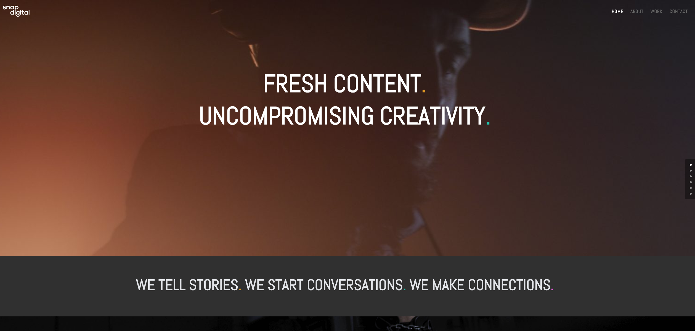SnapDigital are a team of creatives who create commercial films for clients in and around Aberdeen and have collaborated with the likes of BrewDog, BP, UDrafter and many more. Their website is modern and highly visual. On the right hand of the screen they have a unique navigation tab that allows the user to click on which ever.

section of the page they wish to. The drawback to this feature is that these dots are not labelled so unless you knew the website

inside out who do not know which section you are clicking to navigate to.

(SnapDigital, 2019)

*Competitor #2*

‘Connor Ross Media’ is an award winning videographer based in Aberdeen. His website is simplistic and well organized. The first thing you see on his website is his show reel with ‘CONNOR ROSS MEDIA’ layered over the video. This feature is highly visual and instantly will attract the audience to the website.

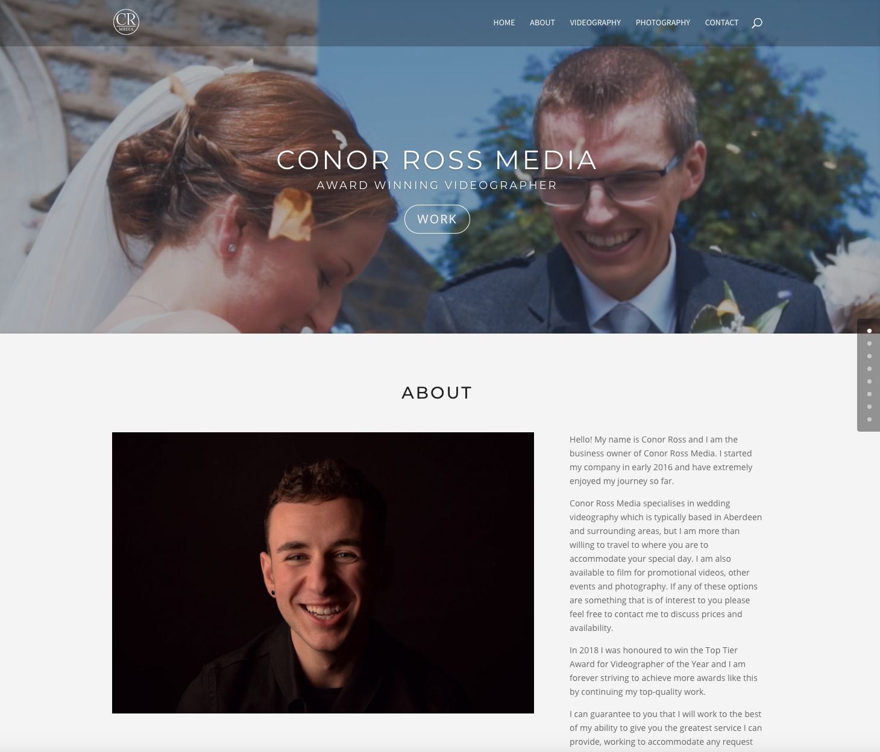

His website comprises of whites, greys and blacks which can often become tedious to the eye and has connotations of little personality.

(ConnorRossMedia, 2019)

Appendices

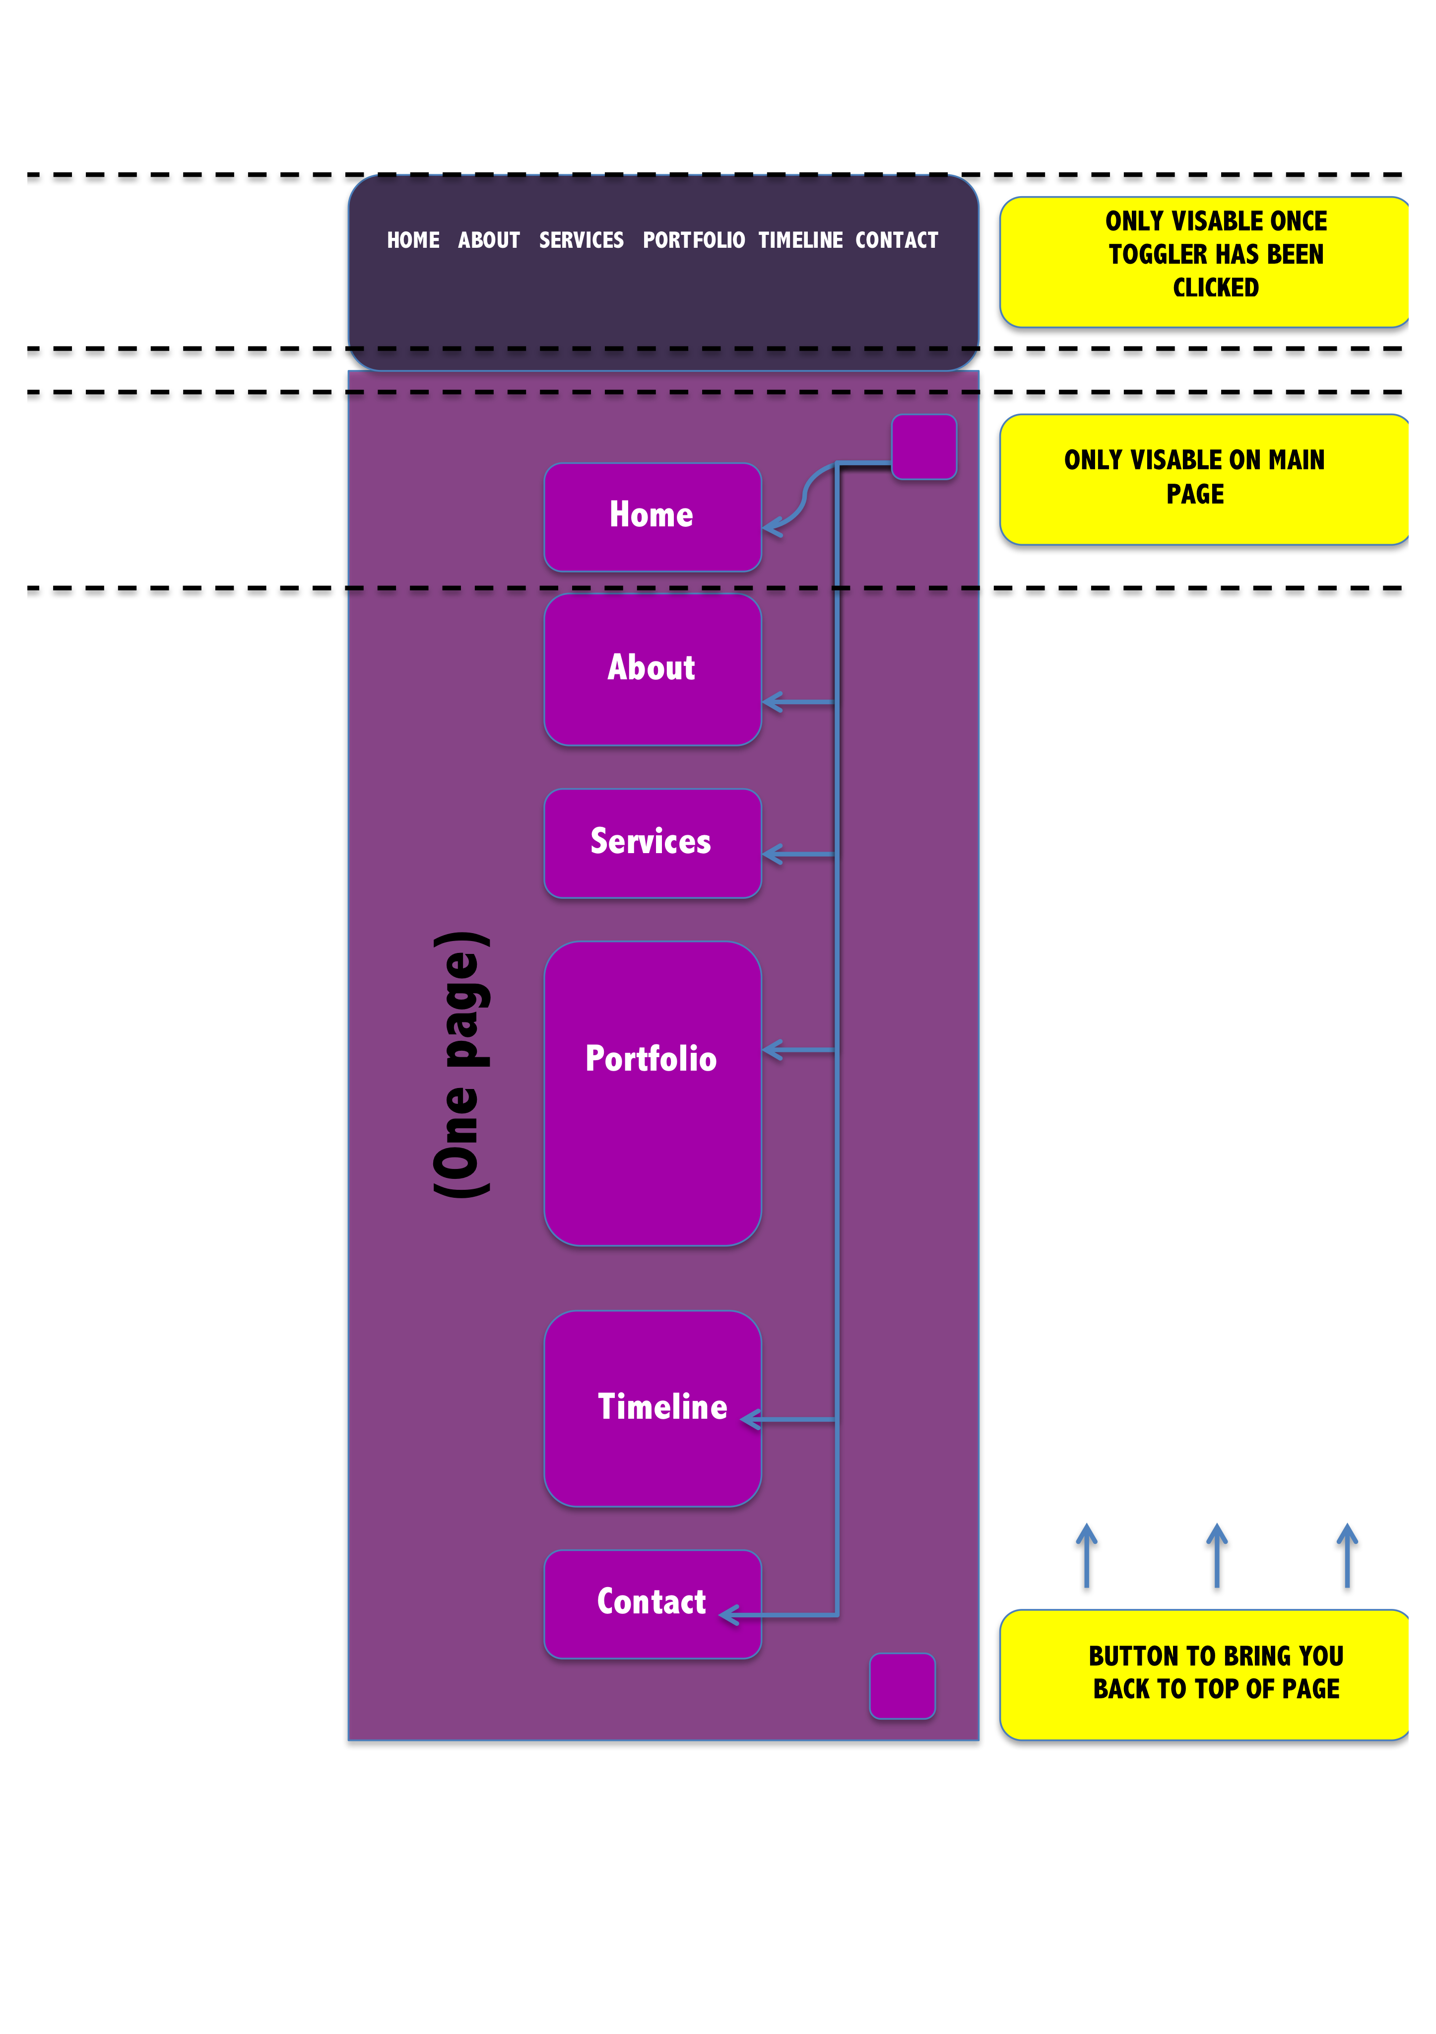Appendix A -Mockup #1

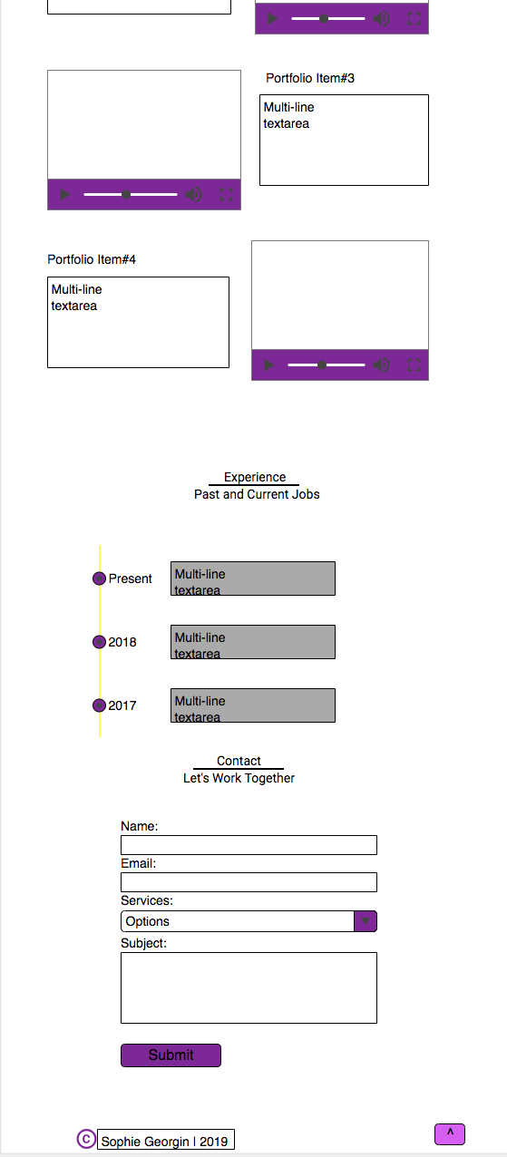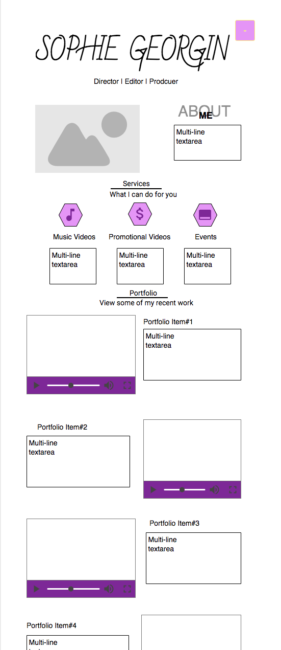

**Appendix B – Mockup #2**

**Appendix C – Website Background Spread**



**Appendix D – Google Chrome Colour Picker**





*(Color-picker.appsmaster.co, 2019)*

# References

Enge, E. (2018). *Mobile vs Desktop Usage in 2018: Mobile widens the gap*. [online] Stone Temple. Available at: https://www.stonetemple.com/mobile-vs-desktop-usage-study/ [Accessed 16 Apr. 2019].

Moran, K. (2015). *The Roots of Minimalism in Web Design*. [online] Nielsen Norman Group. Available at: https://www.nngroup.com/articles/roots-minimalism-web-design/ [Accessed 15 Apr. 2019].

Ramella, B. (2018). *30+ Impressive Web Design Statistics You Need to Know in 2019*. [online] Learn.g2crowd.com. Available at: https://learn.g2crowd.com/web-design-statistics [Accessed 23 Apr. 2019].

Przybyla, D. (2019). *Color Psychology - The Ultimate Guide to Color Meanings*. [online] Color Psychology. Available at: https://www.colorpsychology.org/ [Accessed 23 Apr. 2019].

Taheri, M. (2016). [online] Available at: https://creativemarket.com/blog/what-is-typography [Accessed 23 Apr. 2019].

W3schools.com. (2017). *jQuery Introduction*. [online] Available at: https://www.w3schools.com/jquery/jquery_intro.asp [Accessed 23 Apr. 2019].

Moz. (2019). *SEO 101: What is it, and why is it important? – The Beginner's Guide to SEO*. [online] Available at: https://moz.com/beginners-guide-to-seo/why-search-engine-marketing-is-necessary [Accessed 23 Apr. 2019].

Snap Digital. (2019). *Snap Digital | Fresh Content. Uncomprimising Creativity.*. [online] Available at: https://snapdigitalagency.com/ [Accessed 24 Apr. 2019].

Color-picker.appsmaster.co. (2019). *Color Picker*. [online] Available at: http://color-picker.appsmaster.co/#5100FF [Accessed 25 Apr. 2019].

Conorrossmedia.com. (2019). *Conor Ross Media | PHOTOGRAPHER • FILM MAKER • VIDEO EDITOR*. [online] Available at: http://www.conorrossmedia.com/ [Accessed 24 Apr. 2019].